Lesson 5: Concept, Sample and Presentation Boards

For years, interior designers have relied on concept, sample and presentation boards to help visualise and communicate their ideas. Traditionally, these tools served distinct purposes, but today, the lines between mood boards and concept boards have blurred. In contemporary interior design practice, in an attempt to shorten the time taken in the Design and development phase of a project, mood boards and concept boards have merged into a single, powerful tool that encapsulates both inspiration and direction. However, sample boards remain distinct as they focus specifically on tangible materials and finishes.

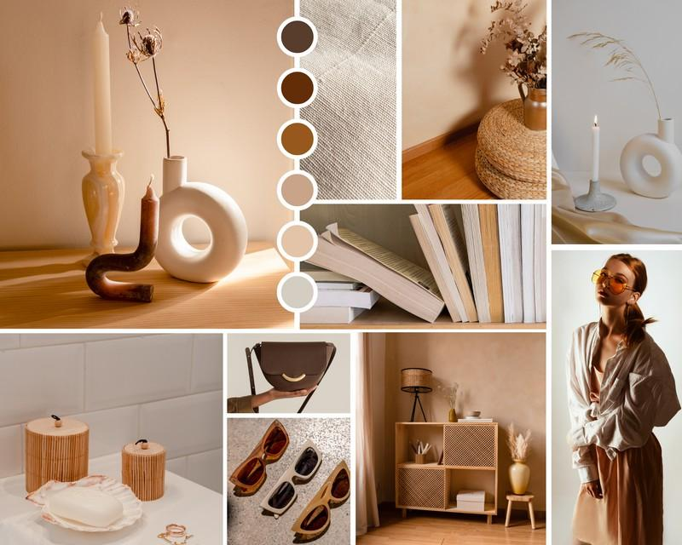

Fig 1. Canva (nd), Brown Concept Board

# The Traditional Distinctions

Mood boards, concept boards, and sample boards were once considered separate entities, each serving a different function:

**Mood Boards:** Primarily used to capture the feeling or atmosphere of a space. They included colours, textures, and imagery that conveyed an emotional or sensory experience. Designers used mood boards to explore the aesthetic and ambiance they wanted to achieve.

**Concept Boards:** More structured and detailed, these presented the foundational ideas of a project, often including sketches, furniture selections, material samples, and even layout suggestions. Concept boards were more about the specifics—how a design would take shape rather than just how it would feel.

**Sample Boards:** Unlike mood and concept boards, sample boards focus on physical materials and finishes. They include actual fabric swatches, flooring samples, paint chips, and other tangible elements that allow clients to touch and feel the proposed materials.

# The Evolution: Merging Mood and Concept

Boards

Over time, the distinction between mood and concept boards has faded. Today, a modern mood board (or concept board) blends elements of both. It combines inspirational images with practical elements, such as ideas for furnishing, finishes and equipment (FF&E), offering a complete visual summary of a design vision. This hybrid approach helps designers not only communicate their aesthetic direction but also outline their execution strategy in one cohesive presentation.

However, sample boards remain a separate, essential tool for presenting physical material selections further down the line, once the Concept is finalised and approved b the client and Market reserach has been completed, in order to choose the final finishes.

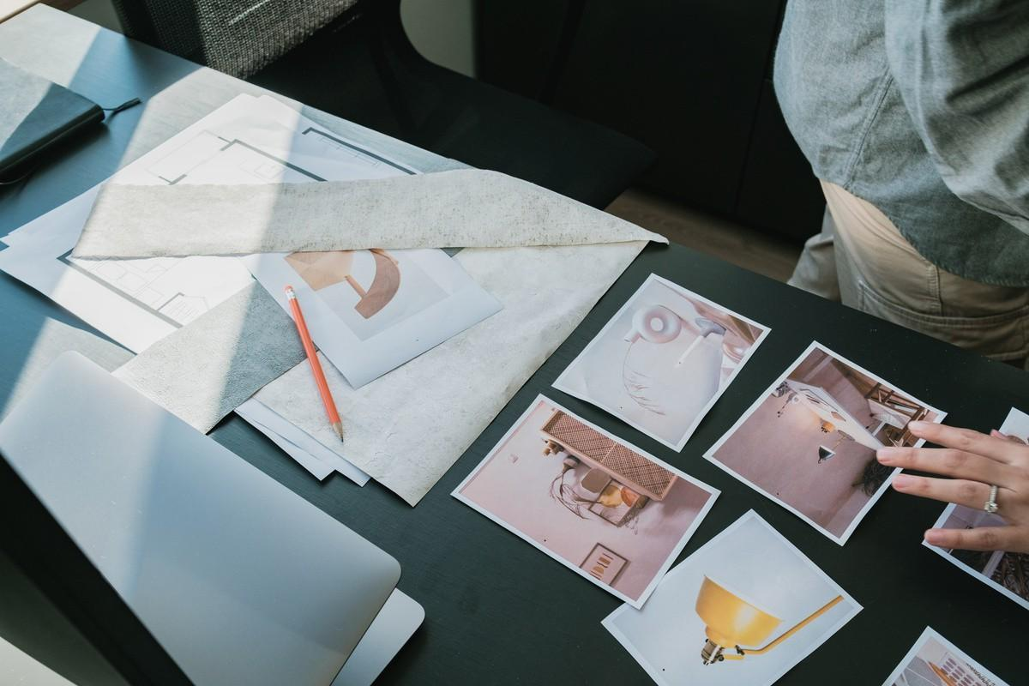

Fig 2. Baseimage (nd) [Interior Designer Creating a Mood Board](https://www.canva.com/photos/MAFT7wsvkOg/)

# How to Create a Mood/Concept Board

A well-structured mood or concept board should include a balanced mix of imagery that define the intended design. Here’s how to create one:

## Gather Inspirational Images:

Collect images that represent the desired mood (atmosphere), these can:

either have a more abstract approach, such as images of sunsets, nature, macrophotography, images that represent your client, or mean something to them (it might be a piece of art they want to use in the space).

could be any images that you associate with the project (images of architecture, graphic design, or other interior projects).

## Define Your Concept

Start with a clear vision of the space. What feeling should it evoke? What is the overarching theme or design style? Use images that represent this.

Consider the client's needs, functionality, and emotional response.

the images used for this part, usually show a “something like this” type of imagery - so if you are envisioning a grey sofa for example, you will show this is an image.

*It is important to remember here, that these images are not final proposals, so your client needs to be aware of this, when you present this visual board.

## Colour Palette

Define a cohesive colour scheme that reflects the mood of the design.

Use colour swatches to show this initial colour scheme and ensure harmony in tones and shades.

## Furniture and Decor Elements

Add specific furniture pieces, lighting, and accessories that align with the concept.

Show a mix of different styles if aiming for an eclectic look, otherwise align the images with the style you are aiming for.

Remember, these images are not exact representations of your final FF&E choices, but they should be relevant.

## Typography and Words

Though not always necessary, and this will be something you will incorporate in your own presentation style, should you wish do to so, adding a few key words or typography elements can reinforce the concept and overall narrative of the design.

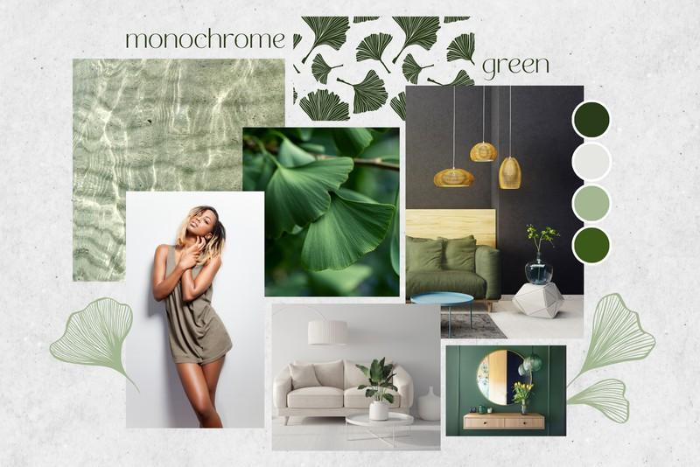

Fig 3. Canva (nd) Green Concept Board

# Digital vs. Physical Boards

With advances in technology, most designers now create digitalconcept boards using tools like Canva, Adobe Photoshop, or Pinterest. These allow for easy adjustments and sharing with clients. However, physical sample boards are still necessary for presenting material finishes and creating a tactile experience.

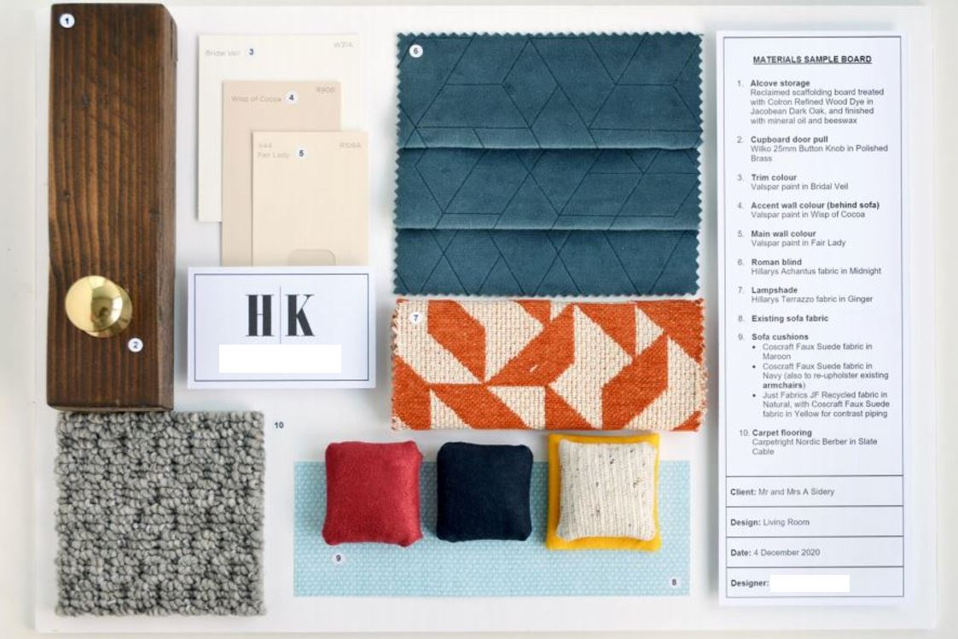

Fig. 4 Physical sample board

In modern interior design, mood boards and concept boards are no longer separate tools but rather an integrated, dynamic way of communicating a design vision. By blending inspiration with execution, they help designers and clients align on a cohesive, well-thought-out aesthetic before implementation. Meanwhile, sample boards remain a crucial part of the process for showcasing actual materials. Whether created digitally or physically, a strong board should tell the story of a space, making the design process both more efficient and visually compelling.